How to create a report of all items which have been declared “Missing” longer than 6 months ago | 
Yoel Kortick
Senior Librarian

- The status “Missing” may be attributed to an item for example
  - Doing the “toggle missing status” in the list of items
  - Via a job “Change physical items”
- Create a new analysis in the physical items subject area
- Display the following fields (you can display other fields according to specific needs, this is just a recommendation)
  - "Modification Date" from the "Physical Item Details" folder
  - "Barcode" from the "Physical Item Details" folder
  - "Title" from the "Bibliographic Details" folder
  - "Location Name" from the "Location" folder
  - "Permanent Call Number" from the "Holding Details" folder
- Filter by the following fields
  - "Process Type" from the "Physical Item Details" folder = 'Missing'
  - "Physical Item Details"."Life Cycle" from the "Physical Item Details" folder does not equal 'Deleted'
  - "Physical Item Details"."Modification Date" from the "Physical Item Details" folder is older than or equal to 6 months ago
  - Here is the text of the sql filter:
"Physical Item Details"."Modification Date" <= TIMESTAMPADD(SQL_TSI_MONTH, -6, CURRENT_DATE)
  - Here is how to do the filter:
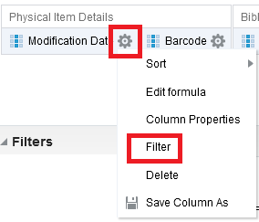
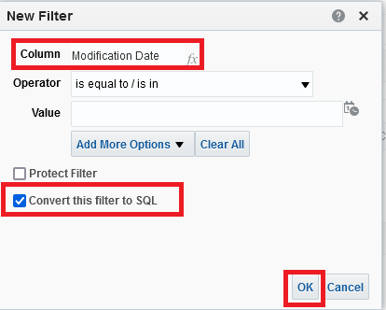
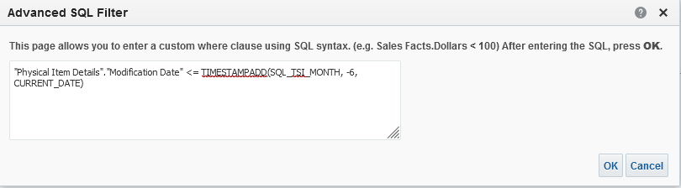
- Here is the criteria tab:
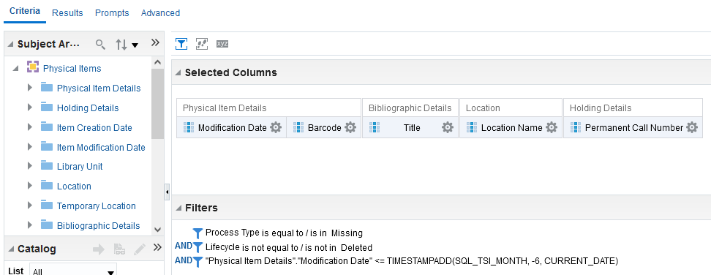
- Here are sample results
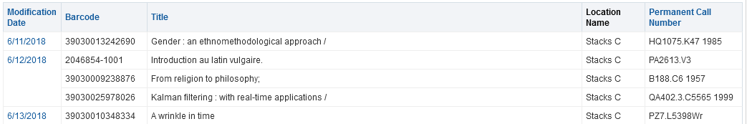
- We will check the first example from the result
  - It is missing
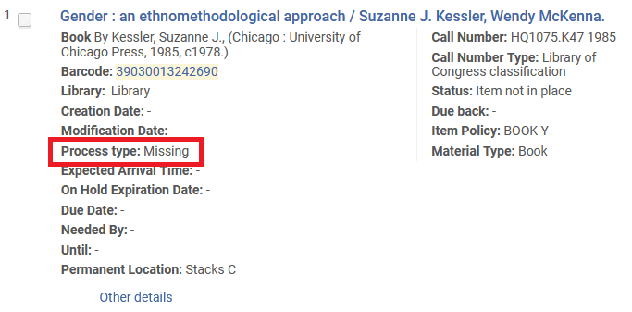
  - It was changed to “Missing” more than six months ago
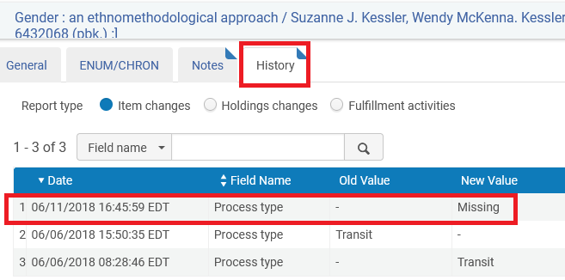
- You can also from here make a report of of all items which have been declared lost longer than 6 months ago
  - This is the “lost” in the list of loans for a patron, or via a job “Loans - Overdue and Lost Item” which uses the “Overdue and Lost Loan Profile”)
  - Make just like above report but instead of
"Physical Item Details"."Process Type" = 'Missing'
Use
"Physical Item Details"."Process Type" = 'Lost'

